Assessing the ‘movescape’ of southern three-banded armadillos (*Tolypeutes matacus*)

**Background**

Based on prior results from the three-banded armadillos, “movescapes” were created in the same fashion as was for the giant armadillos. For simplicity based on prior visualization of other results, all that are included in this document are the plots comparing the habitat selection and time spent per pixel for each site (N and S Pantanal) color-coded by LU/LC and by NDVI. Additionally, continuous-scale and discrete classifications of functional connectivity are mapped for each of the two sites.

**Results**

For the North Pantanal models, pixels fell into one of three different quadrants that represented “slow connectivity”, “impediment”, and “risky” classifications. There was a high level of variability in two of the LU/LC classes (Fence, Pasture), which spanned two different quadrants/classifications. Based on the SSF, there is a negative association between NDVI and habitat selection, which is also highlighted here.

By plotting separate monochromatic color ramps for habitat selection and time spent per pixel, we can gain a relatively nuanced understanding of armadillo functional connectivity. This shows that relatively large dirt paths are selected for by armadillos, where movement is relatively slow. Likewise, cane fields and ranch building areas are associated with fast movements, but are generally avoided. When separated into discrete categories, dirt paths facilitate connectivity through slow movements whereas cane fields and ranch buildings are likely perceived as risky. The remaining pasture area may serve as an impediment to movements throughout the landscape.

For the South Pantanal models, pixels fell into one of two quadrants, which were classified as “fast connectivity” and “slow connectivity”. In general, variability within each LU/LC class was much lower than in the model from the North Pantanal. The opposite relationship with NDVI was found for armadillos in the South Pantanal based on the SSF, albeit a relatively small positive relationship.

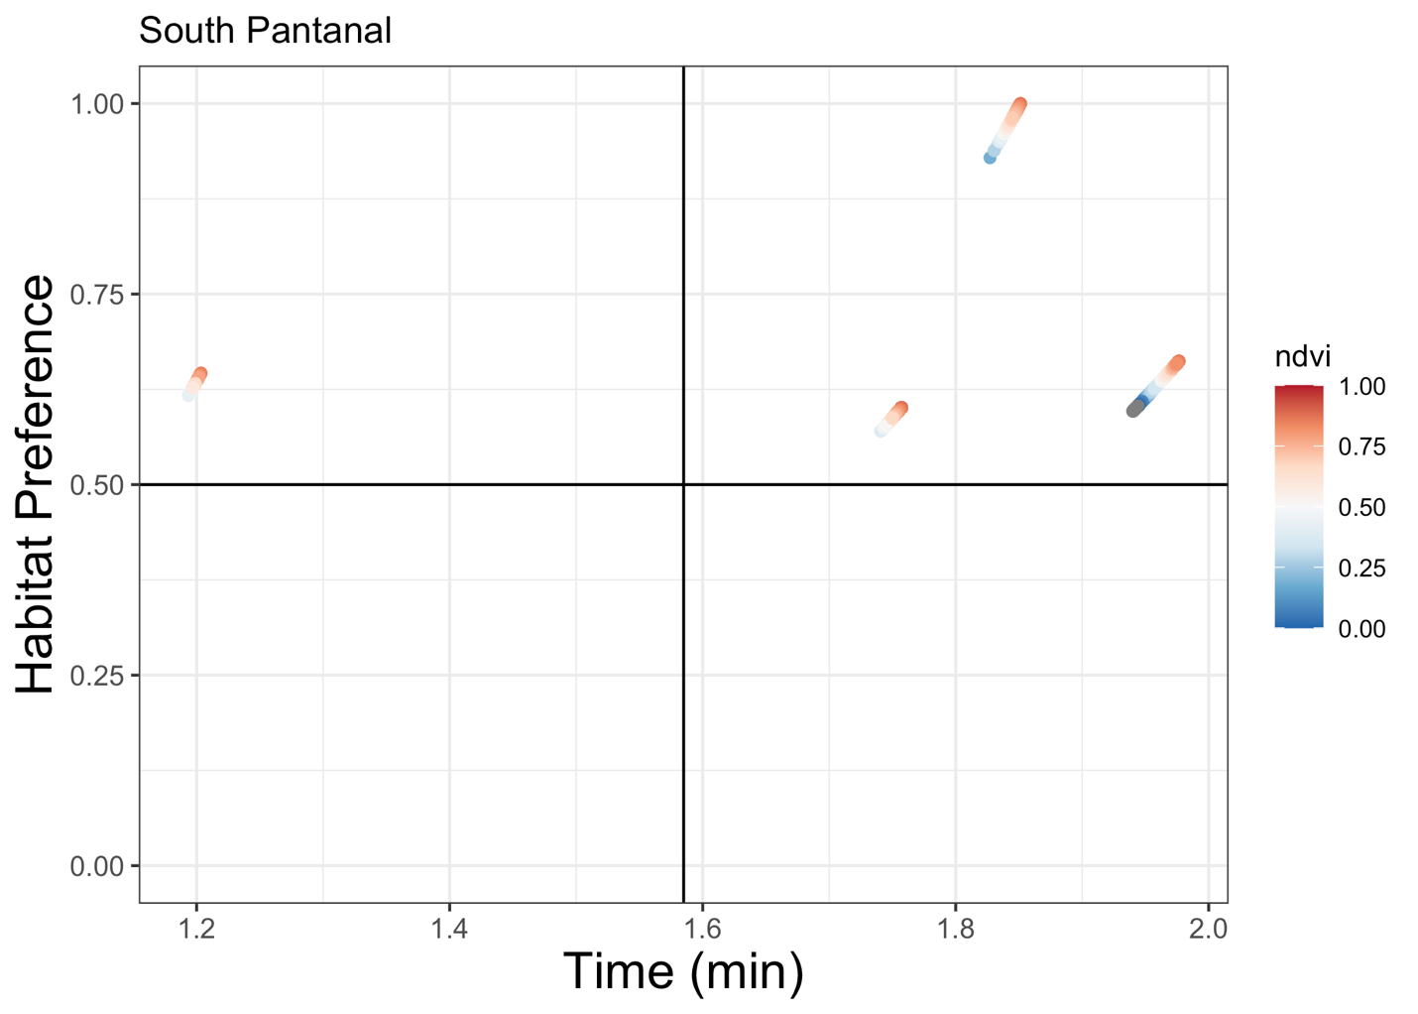

Continuous and discrete ‘movescapes’ were also created for the South Pantanal models. This shows that armadillos at this site prefer and spend a lot of time moving slowly through the native grass pasture (dark purple), but move relatively quickly along roads. When separated into discrete categories, roads facilitate connectivity through fast movements whereas all other land classes (besides water) possibly provide some measure of slower connectivity.

**Discussion**

Per the suggestions brought up in the Discussion for the Giant Armadillo analysis, those could also potentially be implemented here. It is particularly interesting how the response to NDVI differs by location. It may be useful to fit separate SSFs and separate resistance models to account for individual heterogeneity that may be driving these differences. It also may make sense to extract NDVI on a seasonal or monthly basis as was performed for the Giant Armadillos.